Jessica Campbell
ENGL 2010 – MWF 11-12
Collin Hull
Profile
NJ Weedman
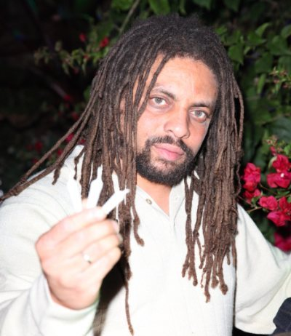
In the last decade Robert Edward Forchion, notoriously known as Weedman, has been an advocate for marijuana legalization. He has run for public office, orchestrated marijuana deliveries, and has outspokenly appealed to the American public for adherence related to the legalization of marijuana. His primary purpose for advocating marijuana legalization is because of his religious beliefs; Forchion is a member of the Jamaican religion, Rastafarian. Forchion has faced a lot of resistance and opposition related to his pro-legalization position, and it has all been in the name of freedom of religion and medicinal use of marijuana.
Robert Edward Forchion (aka. NJ Weedman)
(tlmp.org)
The Rastafarian religion has no formal organization and is considered a "messianic religio-political movement." This religion promotes lifestyle adherence as opposed to ritualistic Protestant based traditions that the majority of American’s follow. The most important points of the Rastafarian lifestyle include the ritual use of marijuana, abstaining from alcohol, vegetarianism, and wearing one’s hair in dreadlocks (religionfacts.com). For those who follow the Rastafarian movement, the use of marijuana is not just for the recreational use, but also for the religious adherence, and perceived physical benefits that are believed to be connected to the drug. Forchion devotedly practices Rastafarianism and openly supports the practice by anyone who desires it.
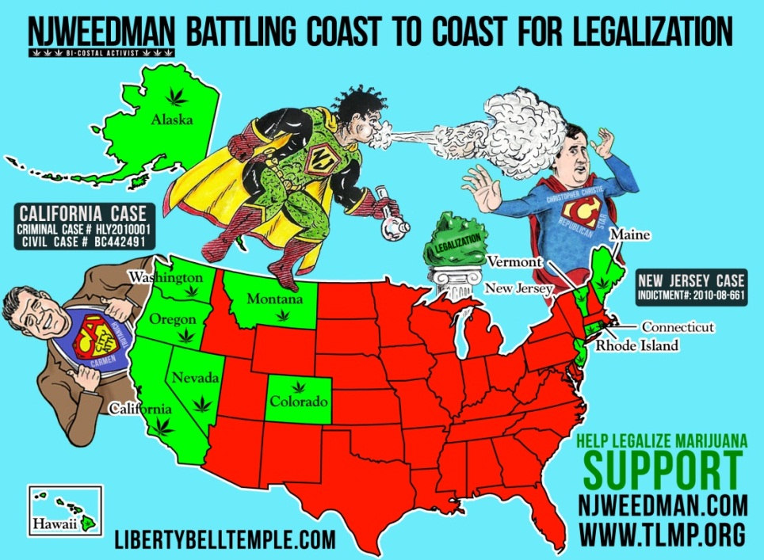
Based partially on his religious beliefs and partially through his personal experiences, Forchion truly believes that marijuana possesses sincere and profound healing powers. He has openly claimed that marijuana has been dismissed as a useless medicinal drug due to political propaganda and Christian moralism. Forchion proudly admits to being a “marijuana smuggler” based on his principal belief that the current United States laws are biased at best and at their root discriminatory against non-Christian religions. He began smuggling marijuana in the mid 1990’s as an effort to help enable the use of marijuana for religious and medical purposes (njweedman.com).
Figure 1: Ed’s promotion of Rastfarian growth and marijuana legalization in the United States (tlmp.org).
In December of 2000, Forchion was convicted of smuggling marijuana and sentenced with 10 years in prison for his actions. He was released after 17 months and warned to stop openly supporting the use of marijuana. He refused to comply with this warning and in 2003 he was imprisoned once again. He appealed that this imprisonment violated his rights under the first amendment. The appeal was judged in his favor and he was once again released (ROBERT EDWARD FORCHION, Plaintiff, v. INTENSIVE SUPERVISED PAROLE, et al., Defendants). This battle has continued on, with a cat-and-mouse back and forth between Forchion, state, and federal authorities. He has continued to promote the illegal use of marijuana, and the state and federal authorities have continued to arrest and prosecute Forchion with various charges. In 2010, Forchion was once again indicted for possession with the intent to distribute, and is awaiting trial (tlmp.org).
Amongst all of the controversy and legal conflict, Forchion has been a trailblazer in establishing a strong Rastafarian community in the United States. He argues that he ought to be protected from legal persecution due to his religious beliefs. In California he has established a Rastafarian Temple where he administers medical marijuana to those with physical ailments and diagnosed illnesses. He is in the process of growing the Rastafarian community in many of the states that recognize medical marijuana as a legal medical treatment. By promoting the legalization of marijuana, he would in turn be promoting the Rastafarian religion.
"What happened was a total sham and mockery. People just blew me off because I was a pothead. I was the little guy fighting the Goliath of government and they took away my slingshot -- jury nullification. It's the 'We the People' weapon." – Robert Edward Forchion (njweedman.com)
In the last few years, Forchion has begun an ambitious publicity campaign to bring awareness to his situation and similar cases nationwide. He attempted to run for legal office under the Marijuana Legalization Party, but failed in his attempts. Even through the many roadblocks that Forchion has come across he perseveres. He wholeheartedly believes that there is a need to fight for the legal right to use marijuana, medically and religiously, in America. The legal ramifications are not a strong deterent for Forchion, as he feel a sense of martyrdom in fighting for his perceived religious rights. As for his impact in the battle to legalize marijuana (see figure 1). Forchion has acknowledged that he has a long fight ahead of him, but he is not prepared to step down. Even through his legal hurdles Forchion fully intends to finish the fight in order to find justice and to exercise his right to the freedom of religion.

Works Cited
The Legalize Marijuana Party. Web. 5 Apr. 2011. http://www.tlmp.org.
"Rastafari, Rasta, Rastafarianism - ReligionFacts." Religion, World Religions, Comparative
Religion - Just the Facts on the World's Religions. Web. 2 Apr. 2011. http://www.religionfacts.com/a-z-religion-index/rastafarianism.htm.
"Bio_ed_forchion." Redirecting. Web. 2 Apr. 2011.
http://www.njweedman.com/bio_ed_forchion.html.
ROBERT EDWARD FORCHION, Plaintiff, v. INTENSIVE SUPERVISED PAROLE, et al., Defendants. No. 02-4331 (JEI). UNITED STATES DISTRICT COURT DISTRICT OF NEW JERSEY. n.d.

